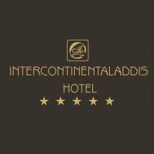

13th African Regional Meeting of the International Labour Organization
Addis Ababa, Ethiopia, 30 November-December 2015

HOTEL RESERVATION FORM
RETURN TO reservation@intercontinentaladdis.com BY 30 SEPTEMBER 2015

INTERCONTINENTAL HOTEL
Guinea Conakry Street
Addis Ababa, Ethiopia
Tel: +251 115 180444
www.intercontinentaladdis.com

Please select room type required:

Intercontinental Hotel | Reservation number 2502478
Deluxe room | USD 133 per night (bed and breakfast)  (incl. service charge and VAT)
Suite | USD 165 per night (bed and breakfast)  (incl. service charge and VAT)

Please complete the following information:

Guest name and surname

Arrival date

Arrival flight no

Arrival flight time

Airport transfer required (yes/no)

Departure date

Departure flight no

Departure flight time

Address

Phone number

E-mail address

Credit card no  (obligatory) |  |  | Credit card expiry date

Please e-mail the completed registration form to reservation@intercontinentaladdis.com or send it by fax to +251 115 540090 before 30 September 2015. Rooms will be allocated on a “first come, first served” basis. Rooms at the negotiated rate cannot be guaranteed unless reserved before 30 September 2015.

